**Amazon Web Services**

**Project-3:** Static Web Hosting on S3 Bucket with name KLUNIVERSITY by generating policy for GetObject.

**Group Members:**

**ID NO Name**

190031063 Mohammad Mustafa

190030717 Kanakavalli Mannava

**Introduction:**

Amazon S3 stands for Amazon Simple Storage Service. We can create a bucket and delete a bucket using Amazon S3.

**GetObject:**

Retrieves objects from Amazon S3. To use GET, you must have READ access to the object. If you grant READ access to the anonymous user, you can return the object without using an authorization header.

**Static Website:**

Static websites deliver HTML, JavaScript, images, video and other files to your website visitors. Static websites are very low cost, provide high-levels of reliability, require almost no IT administration, and scale to handle enterprise-level traffic with no additional work.

**Step by Step Documentation:**

**STEP-1.Bucket Creation:**

**Bucket name: kluniversity717063**

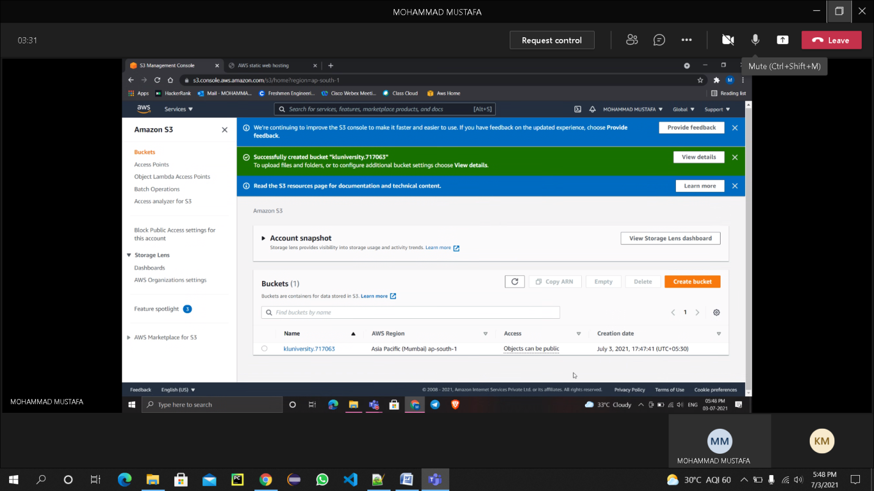

**STEP-2. Uploading File(index.html):**

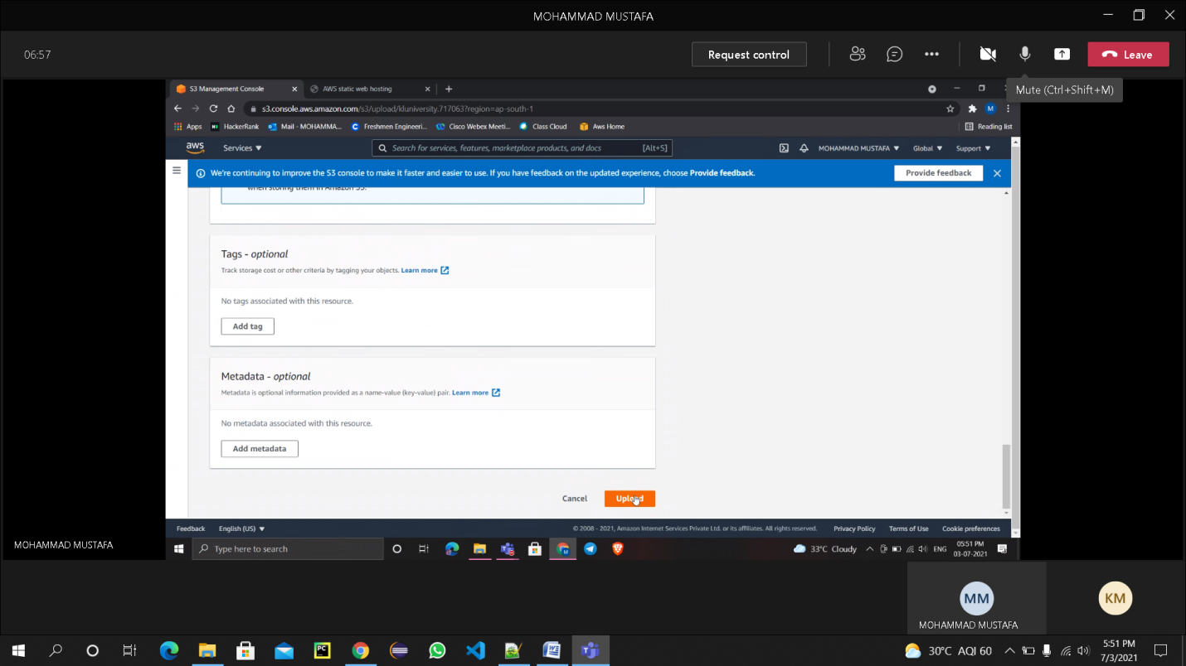

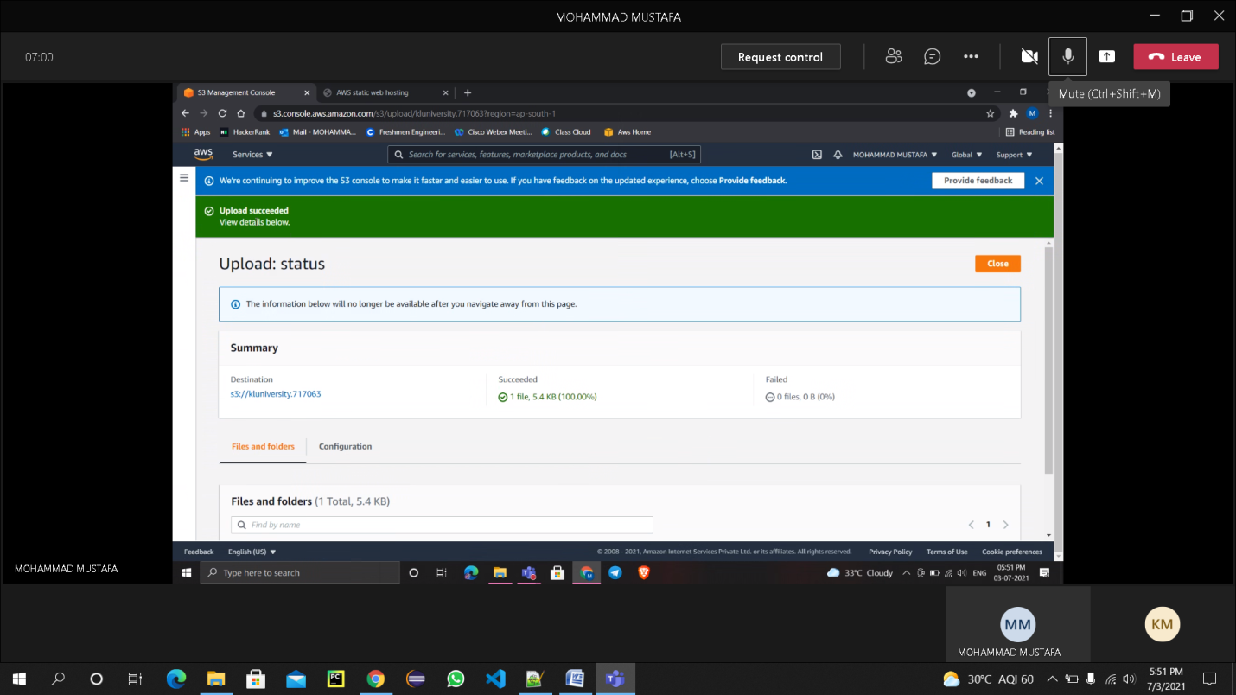

**STEP-3. Grant Public Access to the file(index.html):**

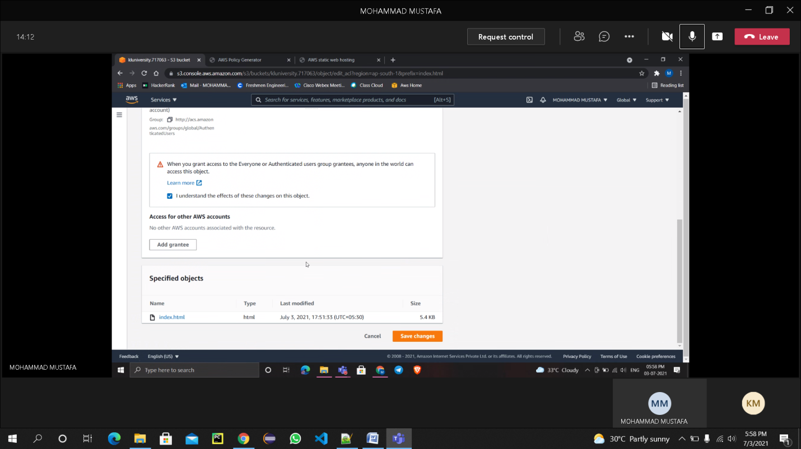

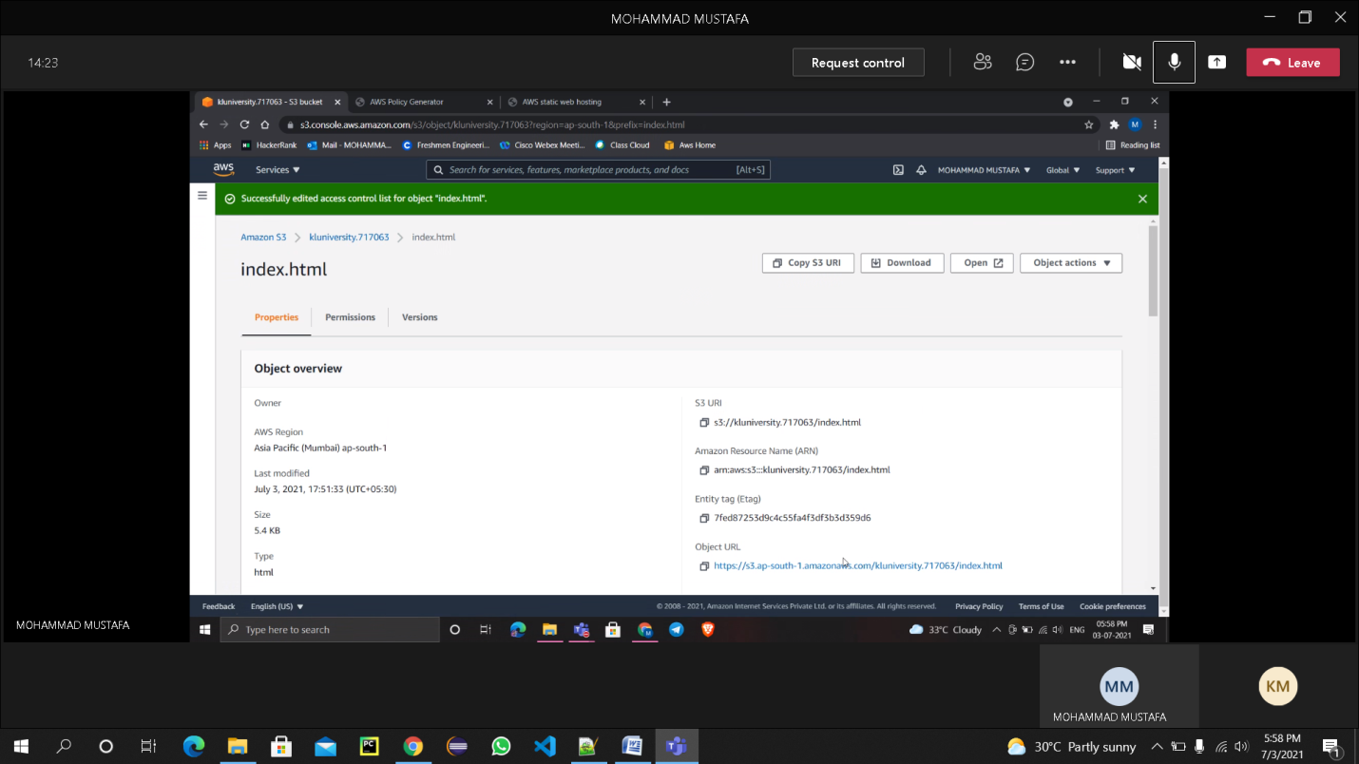

**STEP-4. Generating Policy:**

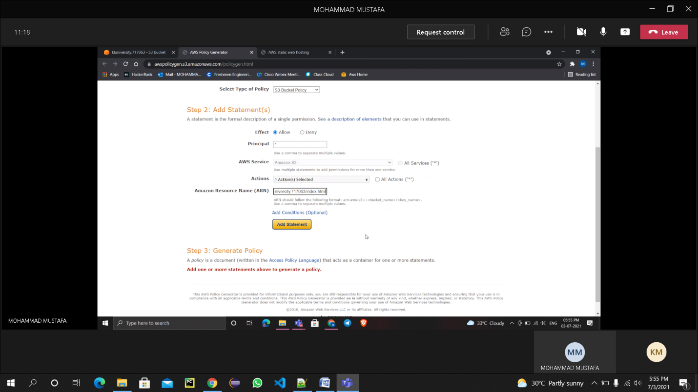

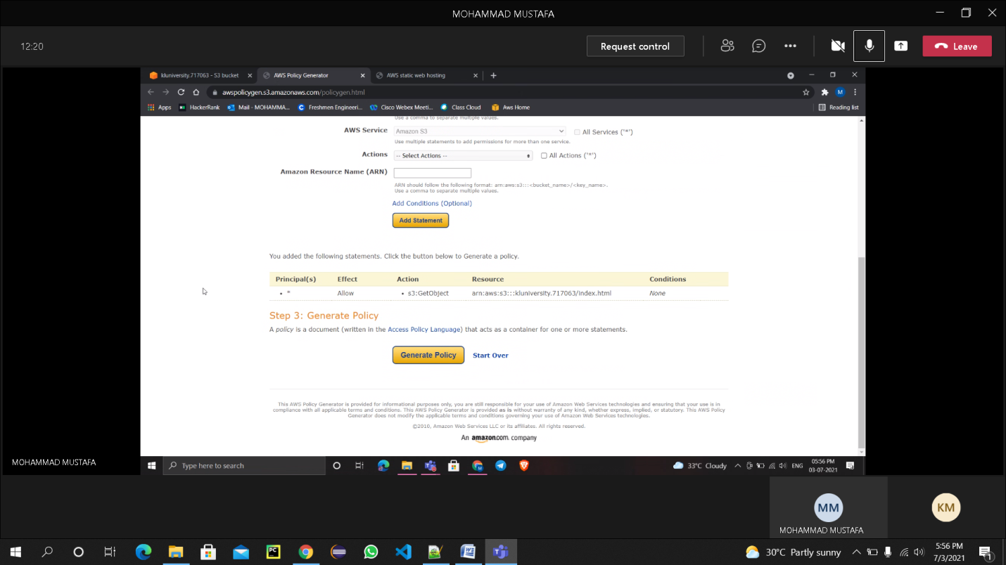

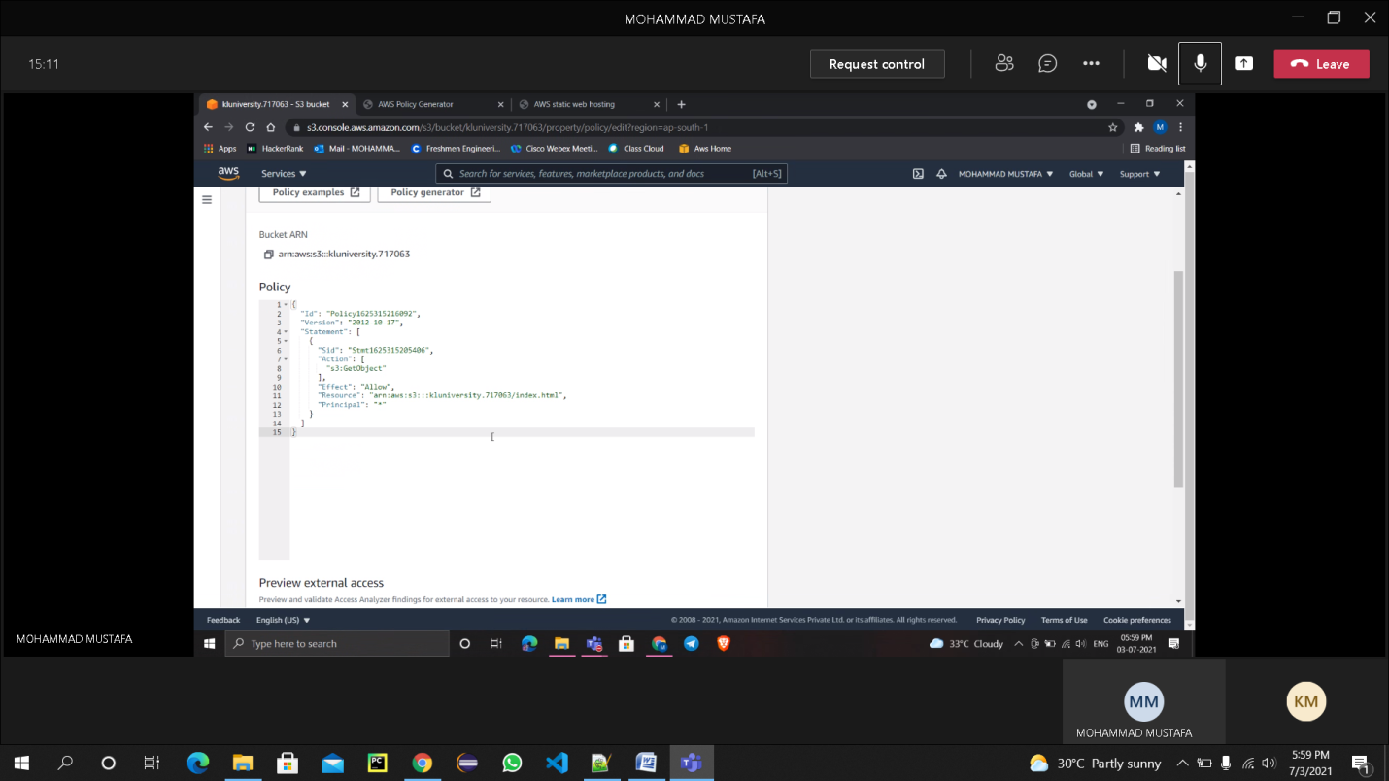

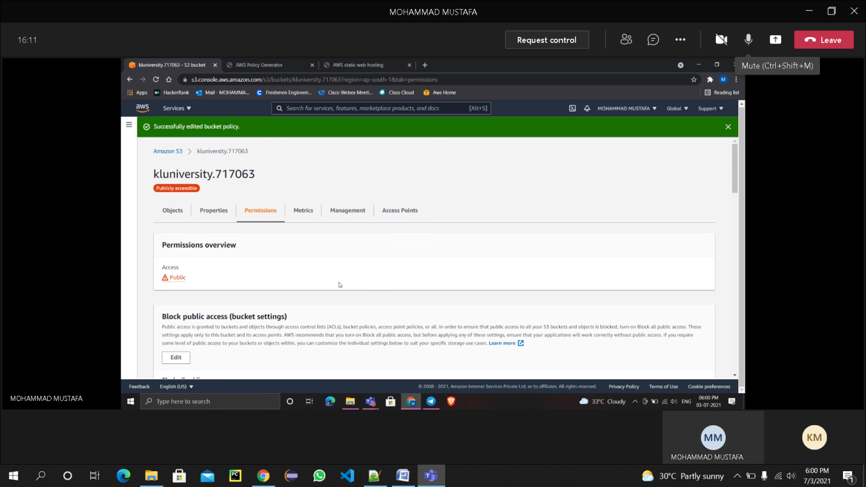

**Bucket Policy :**

**{**

**"Id": "Policy1625315216092",**

**"Version": "2012-10-17",**

**"Statement": [**

**{**

**"Sid": "Stmt1625315205406",**

**"Action": [**

**"s3:GetObject"**

**],**

**"Effect": "Allow",**

**"Resource": "arn:aws:s3:::kluniversity.717063/index.html",**

**"Principal": "*"**

**}**

**]**

**}**

**STEP-5. Enabling Static Web Hosting:**

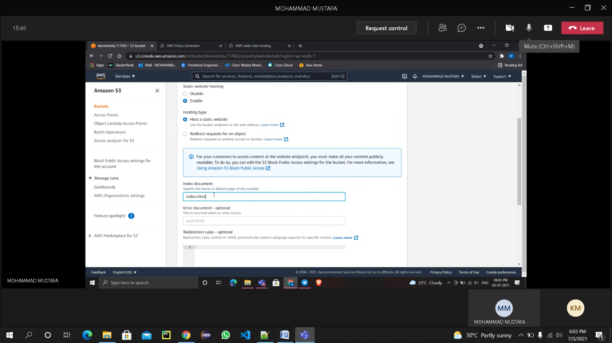

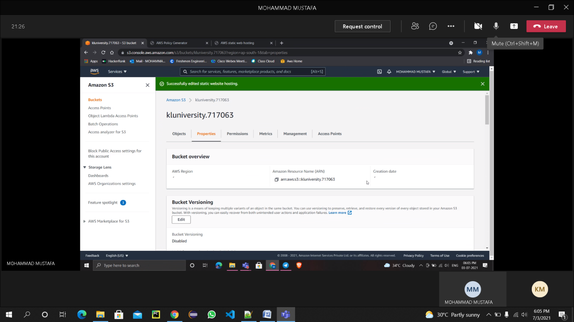

**STEP-6. Upload another File into the Bucket: (index1.html):**

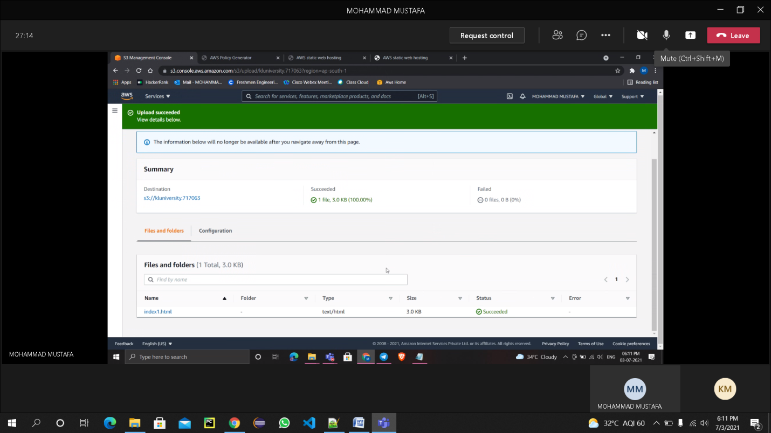

**Object URLs:**

1. [**https://s3.ap-south-1.amazonaws.com/kluniversity.717063/index.html**](https://s3.ap-south-1.amazonaws.com/kluniversity.717063/index.html)
2. [**https://s3.ap-south-1.amazonaws.com/kluniversity.717063/index1.html**](https://s3.ap-south-1.amazonaws.com/kluniversity.717063/index1.html)

**Screenshots:**

